Descriptive title of interesting results in global health (Times New Roman 16 pt bold)

Presenting Q. Author¹, John Q.C. Doe^{1,2}, and Jane Roe² (Times New Roman 13 pt)

¹Department of Microfluidics, University of Global Health, City, COUNTRY (Times New Roman 11 pt)
E-mail: p.q.author@GHuniversity.edu, URL: https://globalhealthworkshop.org
²Department of Public Health, Global Organization, City, COUNTRY

Introduction (Times New Roman 11 pt for section headings and main text)
In this short introduction to your 2-page abstract for the 2021 CBMS Global Health Workshop, you should briefly introduce the context of your study. Describe the aim of the work, and mention whether this is an experimental and/or computational and/or mixed-methods and/or qualitative study. A few references to important prior work in the literature could be given [1,2,3]. End by highlighting the most important results.

Methods: Length and Formatting of the Abstract
An abstract for the Global Health Workshop is limited to two pages in A4 format with 0.5-inch (1.27 cm) margins on all sides, and written in font size 11 pt. For uniformity of the abstract book, please use this abstract template. The main text is set in "Times New Roman 11 pt", and under "Paragraph" all spacings are set to "0" and "Line spacing" is set to "Exactly" and "At 11 pt". You should double check that your final PDF file is A4 before uploading it. Some computers do not convert the page size automatically. Hint: You may need to change your printer default settings. Just printing the PDF from Microsoft Word may not work. To check your page size, in Acrobat under Preferences >Page Display >Page Content and Information; click the box labeled "Always show document page size". This will display the PDF page size for your document so you may confirm the page size is correct
The abstracts for the 2021 CBMS Global Health Workshop are limited to two pages. If a longer abstract is submitted, the extra pages will be discarded and only the first two pages will be reviewed by the scientific committee. All abstract will be reviewed by at least two reviewers. The abstract should contain a Title-Authors-Affiliation section in the style defined by this template, then an Introduction section as described above, followed by Methods, Results and Discussion sections, and ending with two sections entitled Conclusion and References.

Results and Discussion: A Third Section Headline
Your PDF will be reproduced exactly as it is submitted, so please make sure your text has been proofread with care. All figures should be placed as close as possible to where they are mentioned. Please use Times New Roman throughout the entire manuscript, including title, authors, affiliation, headers, sub-headers, figure captions, table headings, and references. To achieve a uniform look across all papers, the format in this sample should be used. Refer to Table 1.

Table 1: Abstract formatting instructions
Text item | Font size | Case | Alignment
Title | 16 pt | Upper and lower case | left, bold
Author and affiliation | 11 pt | Upper and lower case | left, normal
Headers | 11 pt | Upper and lower case | left, bold
Main text | 11 pt | Upper and lower case | justified, normal
Table/Figure caption | 10 pt | Upper and lower case | justified, normal
References | 10 pt | Upper and lower case | justified, normal

If you’d like a figure to describe your work, refer to Figure 1 as an example.

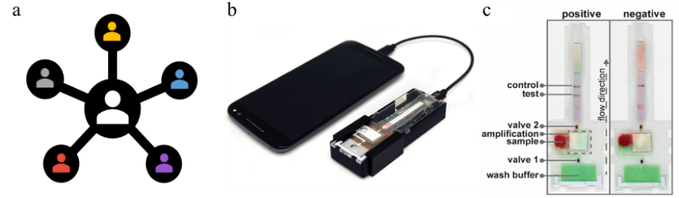 | Figure 1: Perhaps you want a figure with a caption to the right, then follow the setup defined here. (a) Description of the first sub-figure. (b) The next sub-figure. (c) Last but not least, the third sub-figure. Note that the font size of the caption is 10 pt. This figure is placed in a 1×2 Table with invisible borders to enable convenient alignment.

Conclusion
We have some amazing results, which we are looking forward to presenting and discussing with the global health community at the 2021 CBMS Global Health Workshop virtual conference on July 12th and 13th, 2021.

References (Times New Roman 10 pt)
[1] P. Author, O. Coauthor, and A. Coauthor. Journal Name 12, 4617-4627 (2012).
[2] P. Author. A book title, Publishing Company (Publishing City, 2015).
[3] A. Coauthor. Procs. pp. 124-127, International Conference, Conference City, 1 - 6 July 2014.

